**DAY 2:**

Write a Program to display the pattern like pyramid using the alphabet.

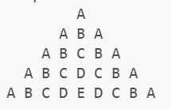

**Details:**

The program is used to print the above pattern using multiple loops.

**Inputs:**

Take the number of rows as an Input.

**Outputs:**

The pattern

**Sample:**

Inputs

5

Outputs:  
